Login to the application

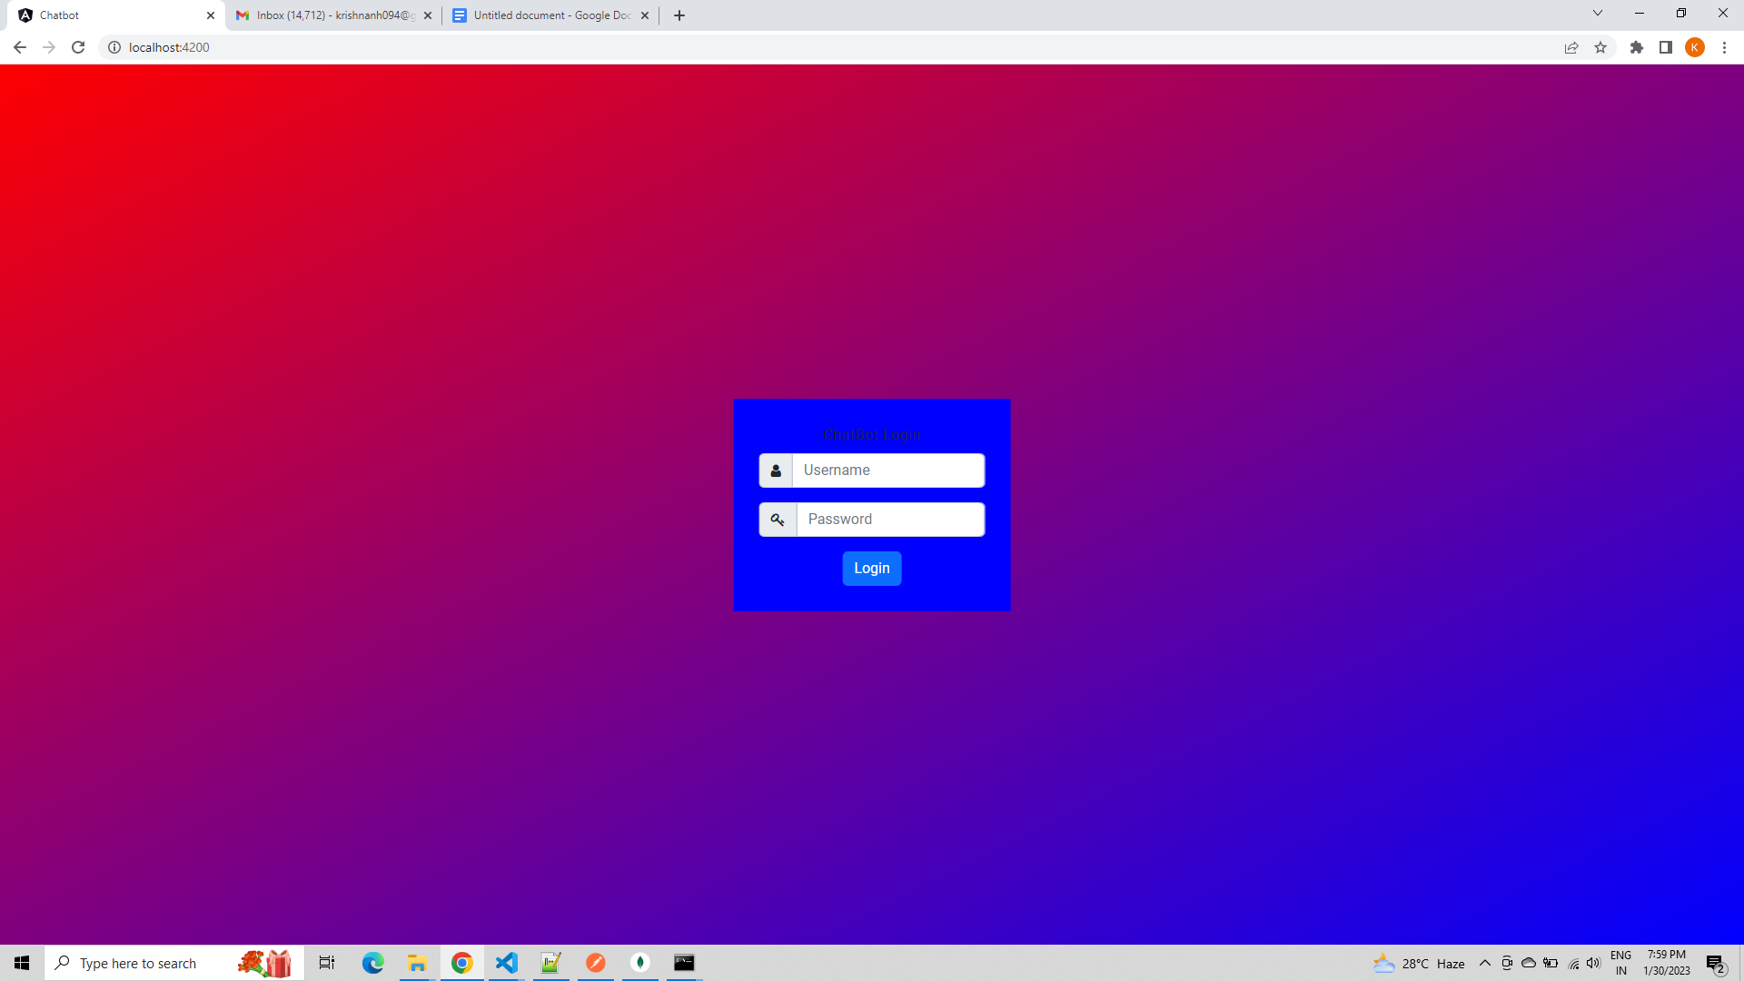

Enter the credentials

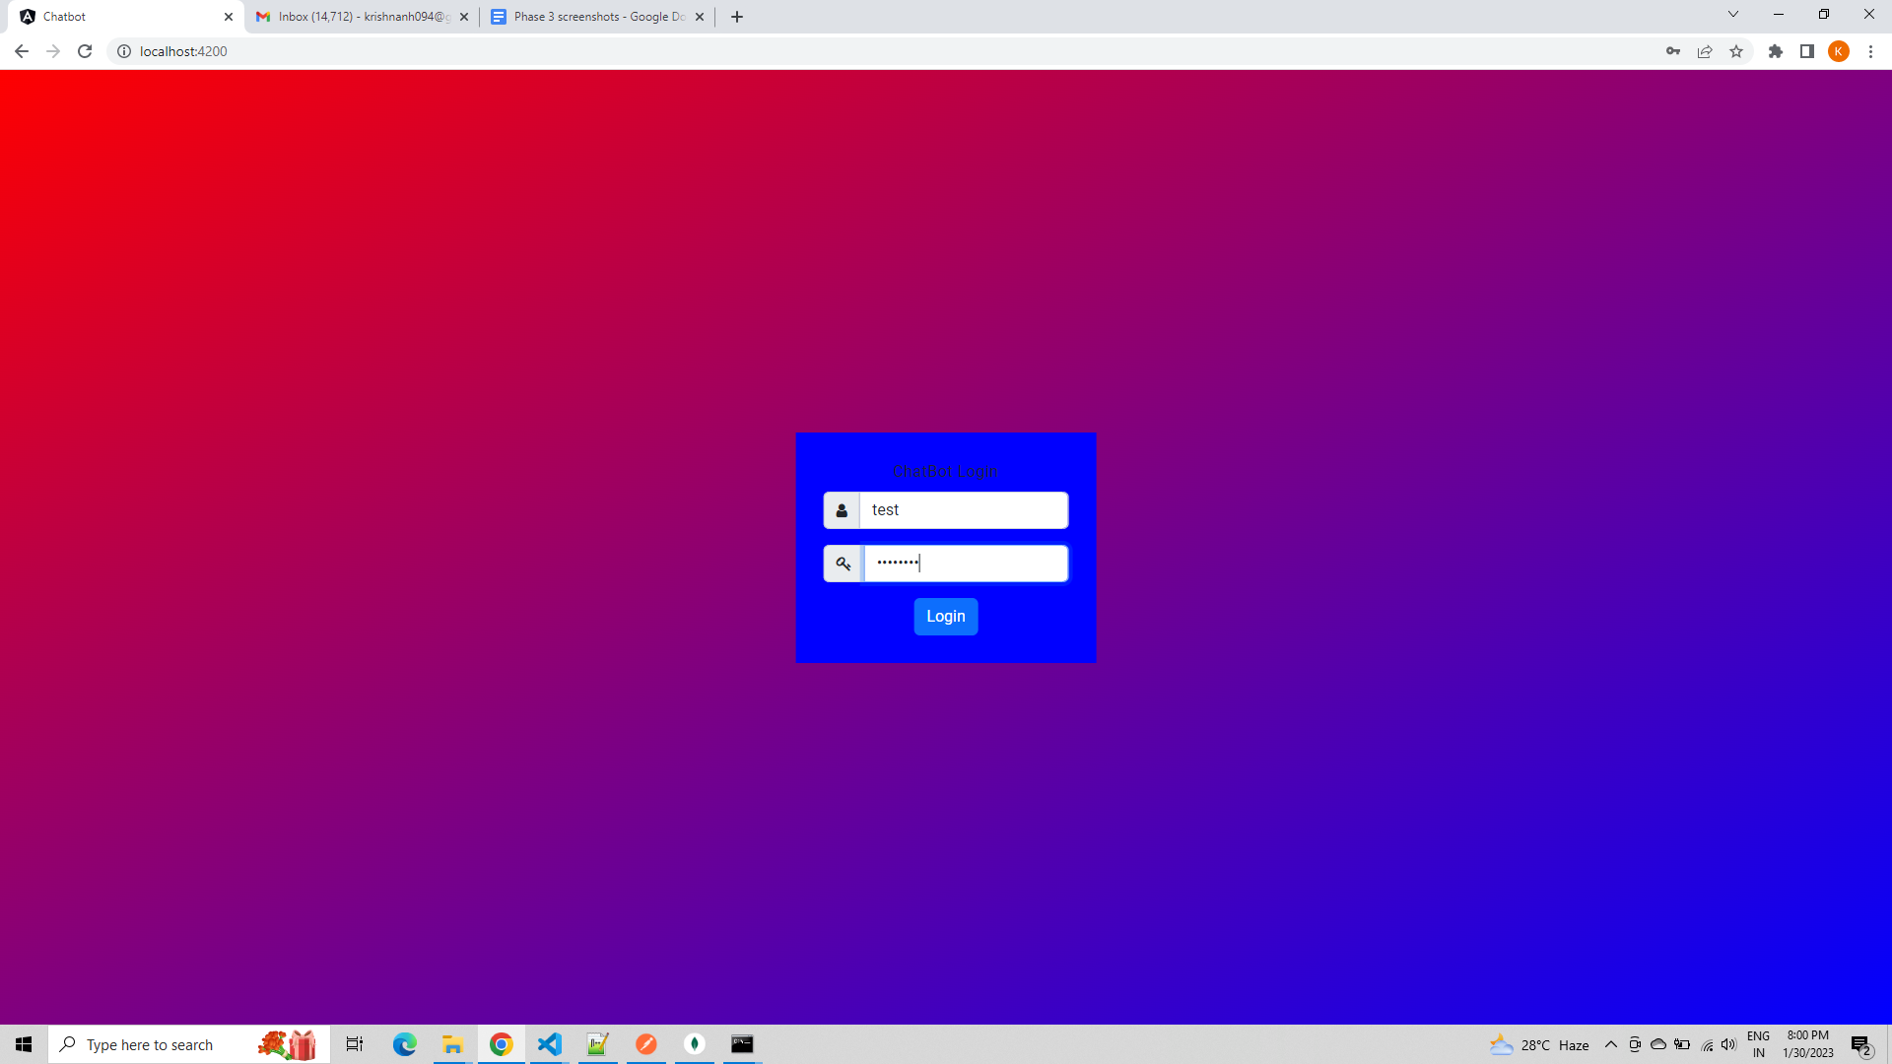

Navigated to chat bot

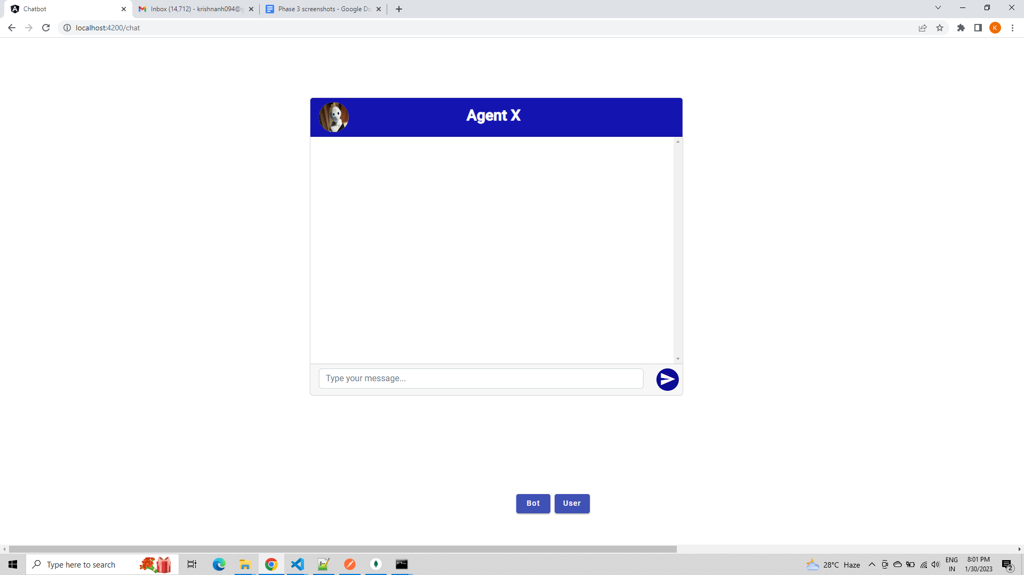

Based on the selection, the user can switch between user and bot and enter information. The details are stored in the MongoDB. The default chat is done by Bot.

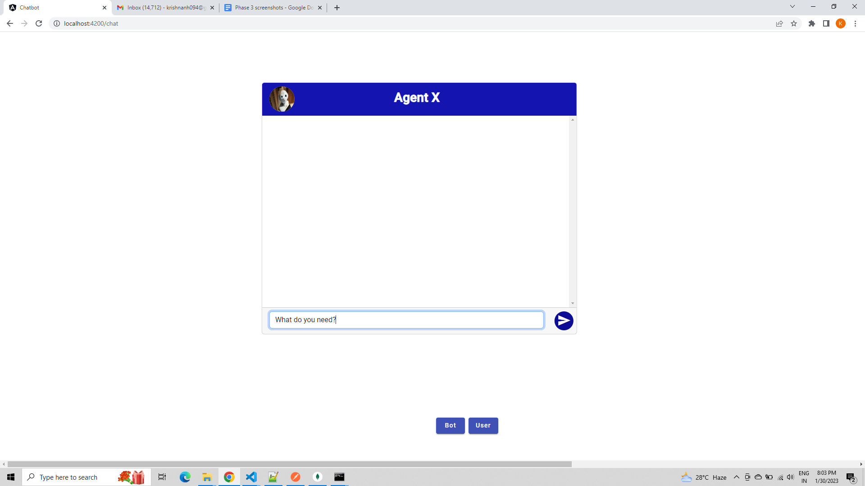

On clicking send, the entered text appears in the window.

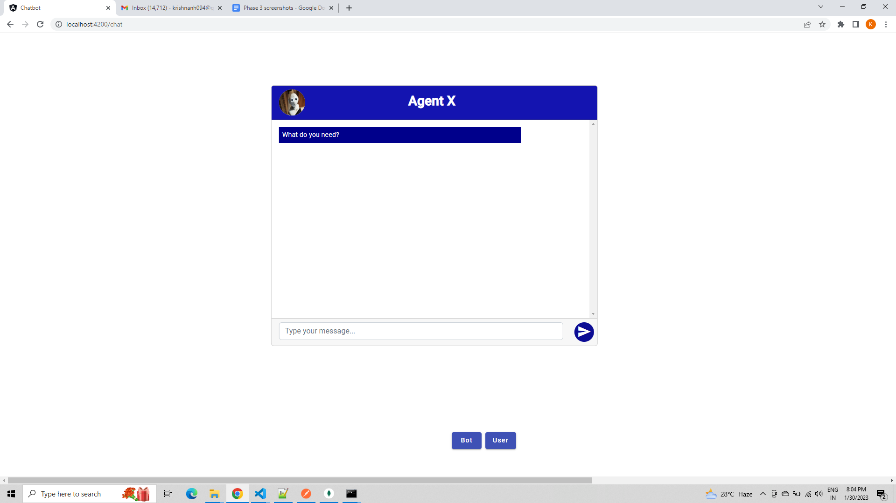

Now, we can switch to user and then enter the required value.

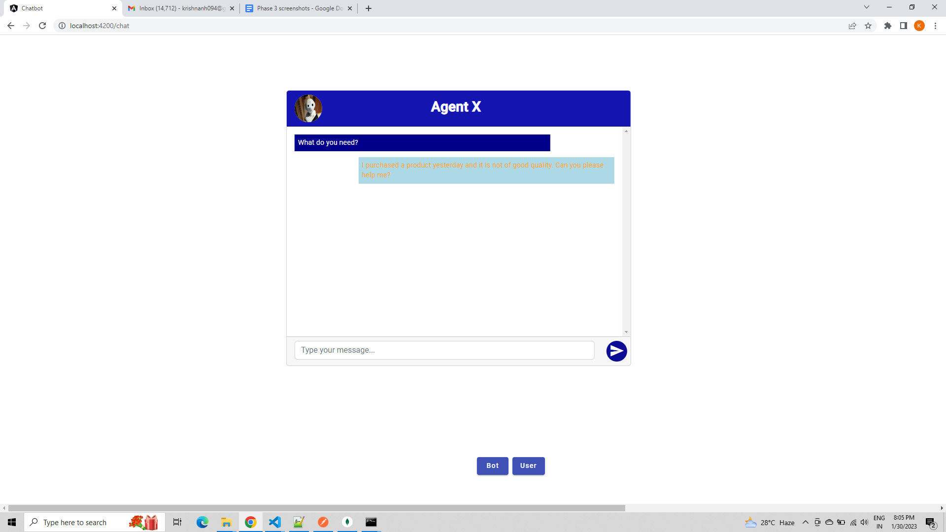

Reply by the bot as entered by the user.

